
Project Title: Making Your WhatsApp Conversations Smarter with Intelligent Reminders
Chanakya UG Fellowship
iHUB DivyaSampark
Month 3: Report
Flutter Code Development, NER Model development
@IIT Roorkee
Submitted By:
Anu S M (UG 211)
Akshay S (UG 212)
Venkatesh R (UG 213)
Mentor:
Dr M N Thippeswamy, Head and Professor
Department Of CSE(AI&ML) and CSE (Cyber Security) Engineering
Pages Implementation: Get Started, Login, and Signup

Get Started Page:
The "Get Started" page serves as the entry point for users who are new to our application. Upon landing on this page, users are introduced to the core features and benefits of our app, encouraging them to sign up and explore further. The page design is minimalist, focusing on clear and concise messaging to engage users effectively.

Login Page:
The "Login" page provides existing users with a secure way to access their accounts. Users are prompted to enter their credentials (email/username and password) to log in successfully. Additionally, the page incorporates error handling to provide informative messages in case of invalid credentials or other login-related issues.

Signup Page:
The "Signup" page enables new users to create accounts and join our platform. It features a user-friendly form where individuals can input their necessary information, including email, password, and any additional details required for registration. The page validates user input to ensure data accuracy and includes error handling for any registration errors.

Screenshots of the pages
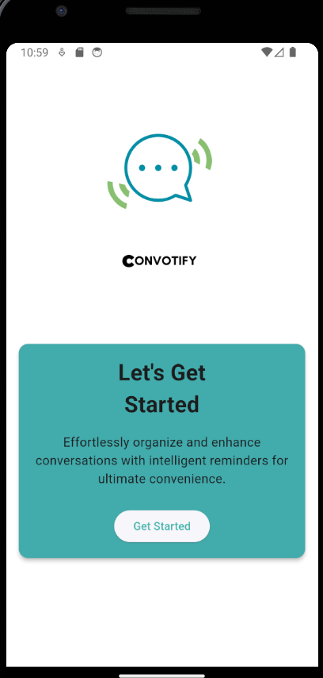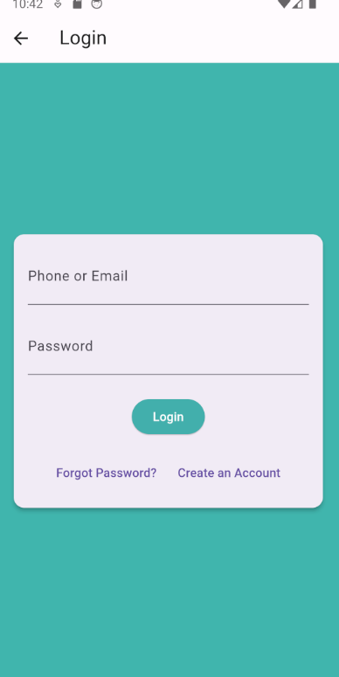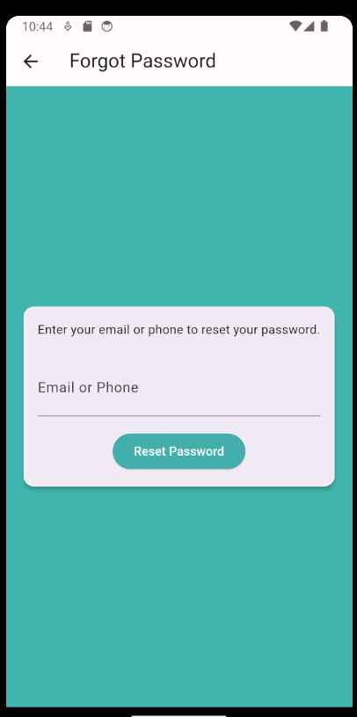
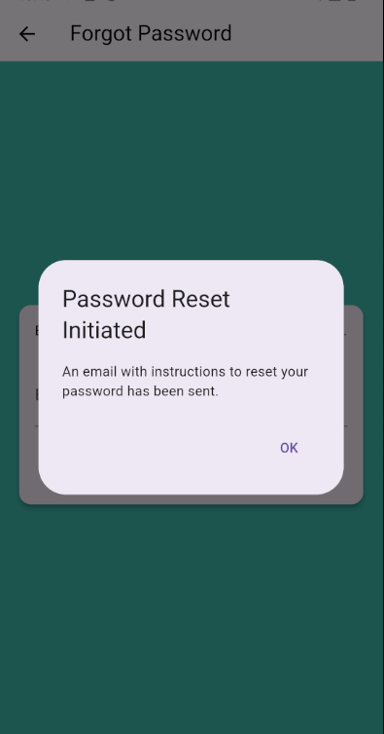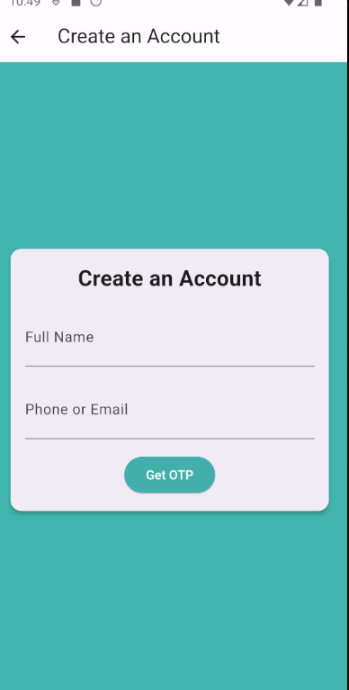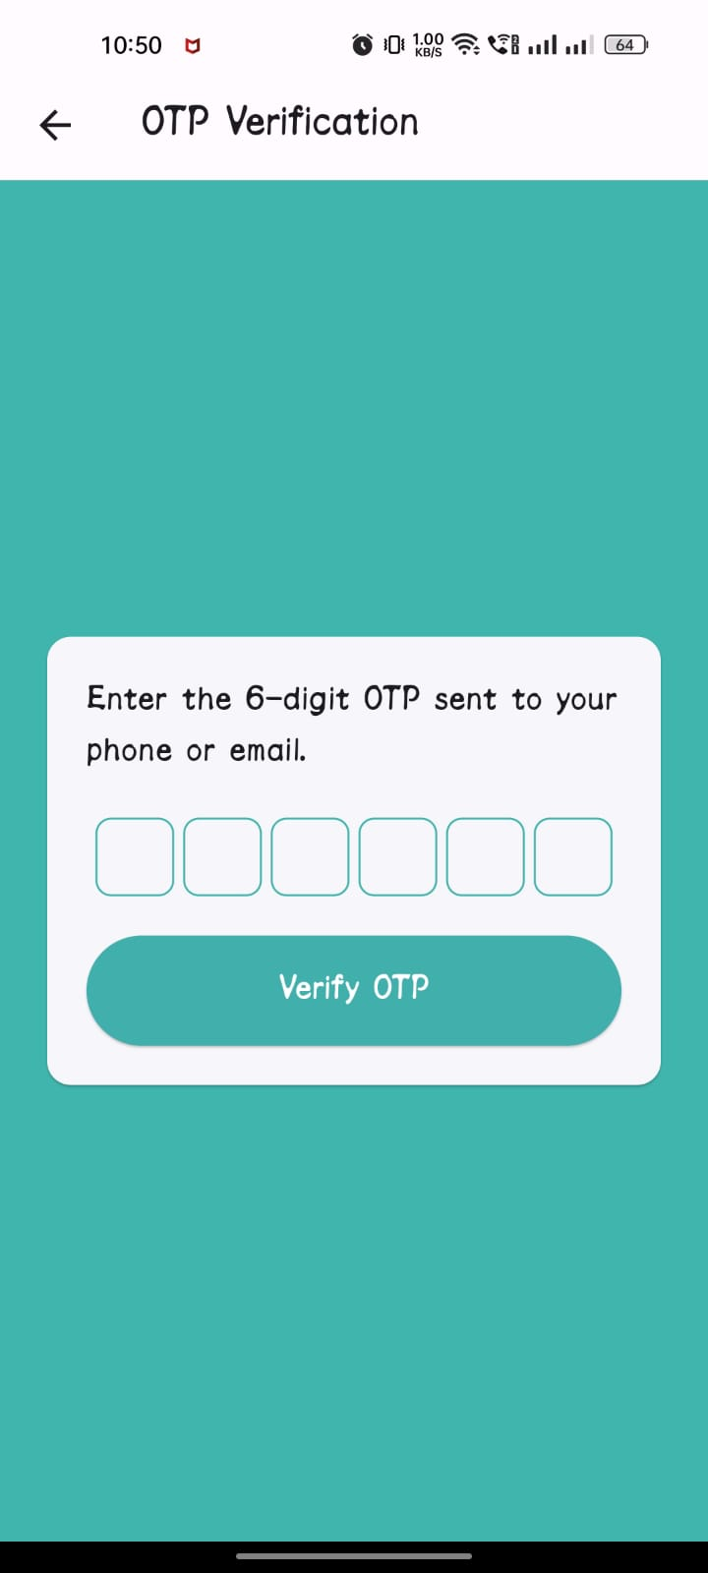

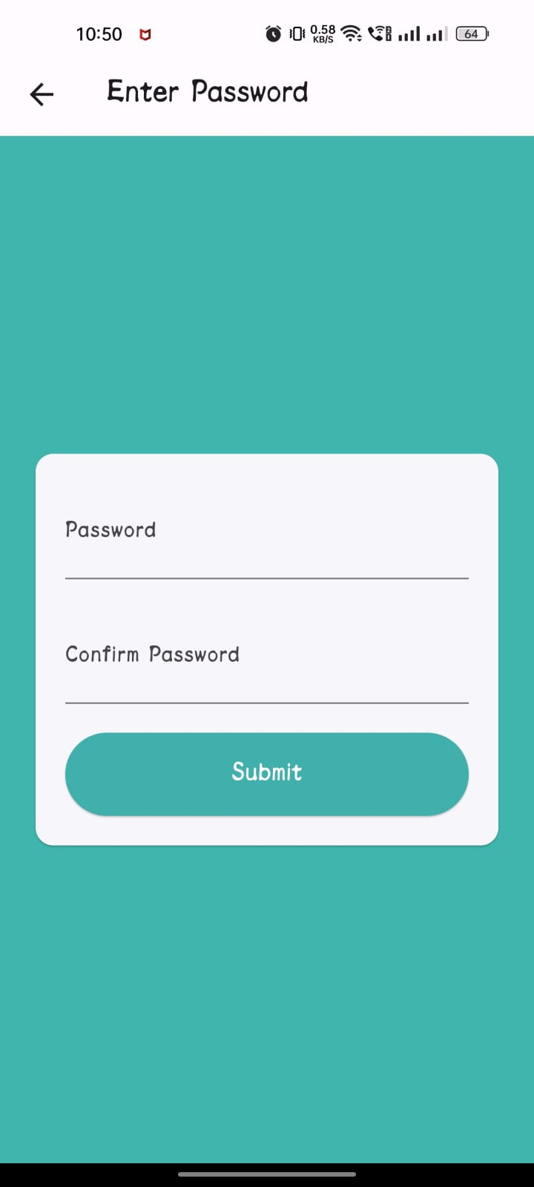

NER Model Development
Trained the NER Model with Available data, the accuracy is 98.88%.
https://huggingface.co/Venkatesh4342/deberta-v3-base-Whatsapp-ner
